PriOSS Prototype Concept

This document describes the general concept for the prototype focusing on the user’s navigation experience and general features. Concrete visualizations/privacy control features have been described in the paper’s discussion section and will be listed in more detail in a future requirements document.

# General Features

The prototype offers instructions on obtaining your personal datadownload from Spotify, Instagram and Facebook. It supports inputting one of these datadownloads, so the prototype can read it in and visualize it and offer different privacy focused controls for it. The data is handled completely on the client side, it is not uploaded anywhere. By default, the application does not access the internet in any way. Some visualizations might need to request some data, for example the mood-visualization for Spotify songs needs to call Spotify’s API to request information about the songs present in the user’s datadownload. The user will be informed about this when accessing the respective visualization and can opt-in to this limited online-functionality. There will not be any internet-connectivity by the app without user consent.

# Navigation

The app starts on a landing page that broadly explains what the app can do for the user. The landing page, when accessed on a laptop, will approximately look like this:

Ein Bild, das Text, Screenshot, Monitor, Anzeige enthält.

The “Explore”-Button leads to the service-selection screen where the user can select a service to show download instructions for:

Ein Bild, das Text, Screenshot, Elektronik, Anzeige enthält.

Selecting, for example, Spotify will lead to the following page where download instructions and a field to select a datadownload is shown. This page looks the same for all services, only the shown instructions differ.

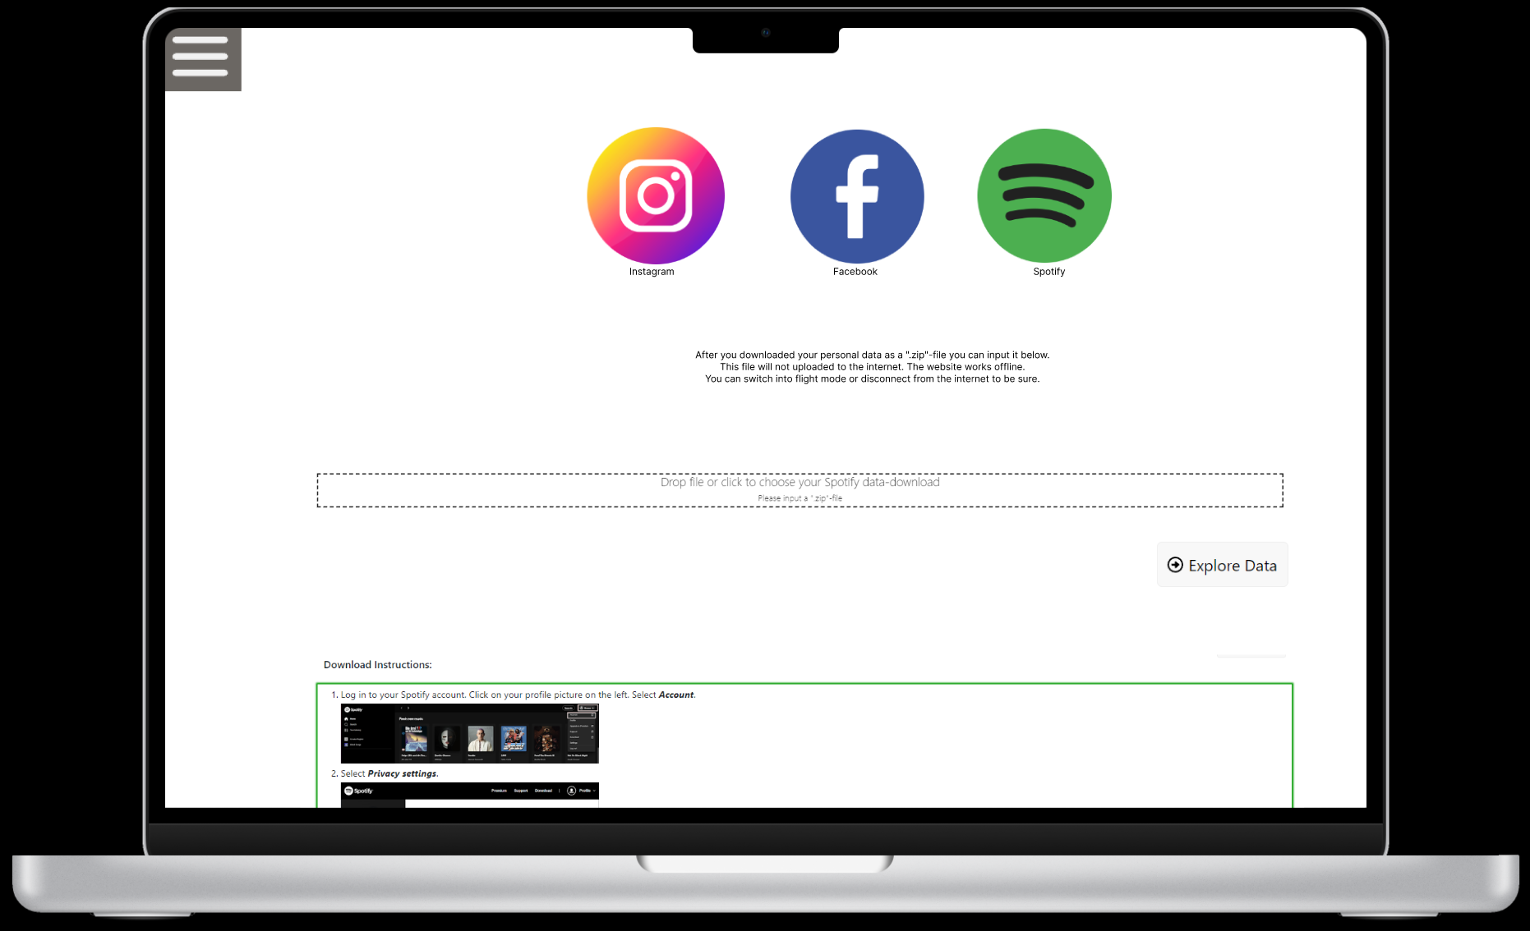

Scrolling down, the user can access the instructions and follow them to request their datadownload. After obtaining it they can input the file into the upload field in the middle of the page and click “Explore Data”. This will make the app read in the data from the given datadownload and lead the user to the dashboard of the respective service.

The dashboard is different for each service, depending on the offered visualizations and available data in the datadownload but follows the same design principles to make users recognize as much as possible between the different apps if they switch between inspecting their different data downloads. The dashboard is supposed to show an overview of the data and previews of the different visualizations / controls available. For the first prototype version, we are planning on displaying different tiles, one for each visualization but this will be revamped once more concrete plans exist for all the different visualizations will be developing.

The dashboard with some initial preview tiles could look like this:

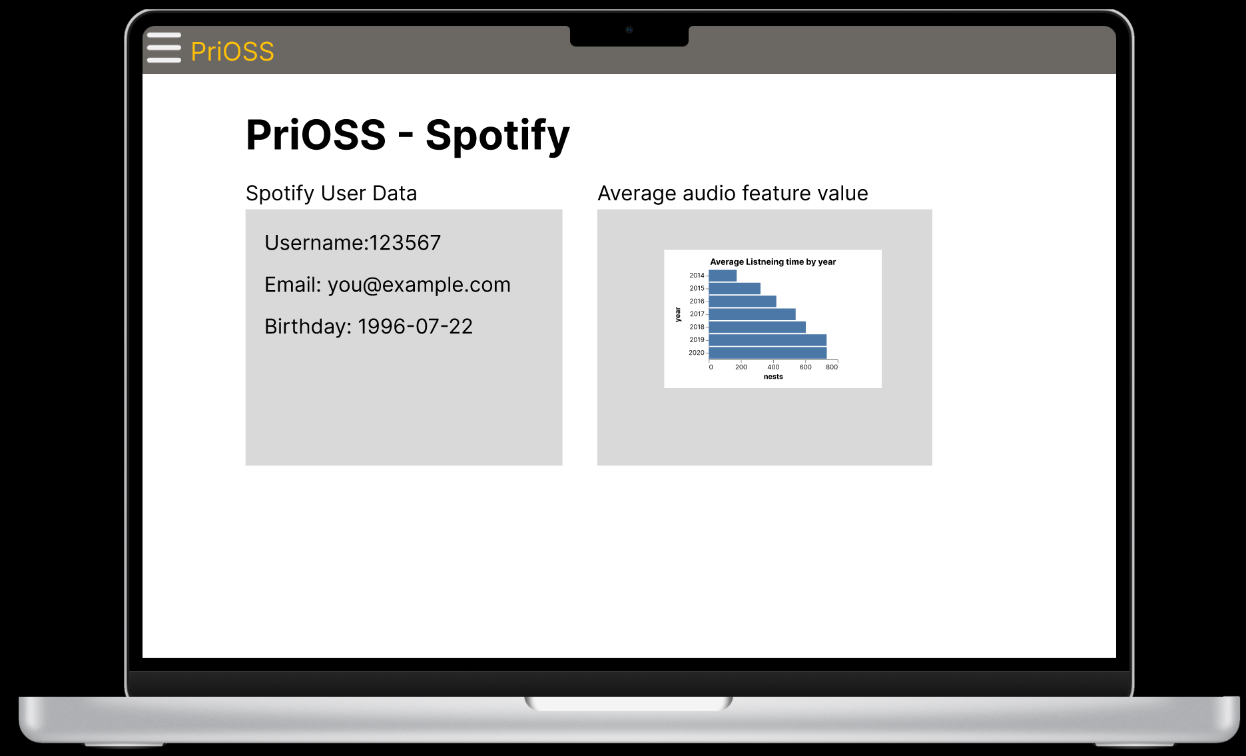

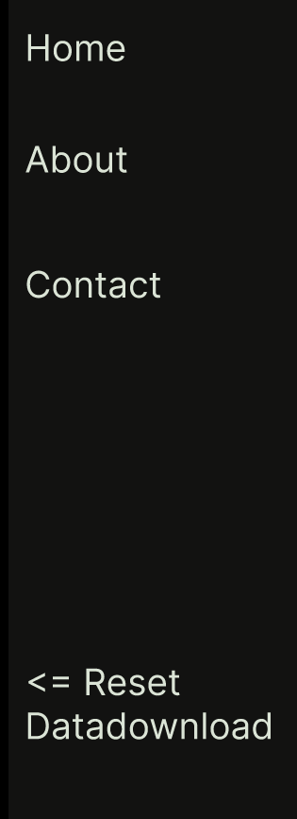The Menu-button () opens a side-menu with different high-level navigation options. “Home” will lead to the landing page if no datadownload was read in already and to the correct dashboard if a datadownload is already present.  
“About” and “Contact” will lead to general information / contact pages about the project. “Reset Datadownload” leads back to the service selection page with a notification that your previously selected datadownload has been removed. This makes it easy to switch between datadownloads or get back to the dashboard while using the app.